MINI PROJECT-II

(2020-2021)

**On**

**“Live Search Weather App”**

**PROJECT SYNOPSIS**



**Institute of Engineering & Technology**

**Submitted by:-**

Ashish Agarwal (181500137-C)

Mohan Agrawal (181500385-I)

**Supervised By:-**

Mr. Akash Kumar Choudhary

**Technical Trainer**

**Department of Computer Engineering & Applications**

**Name / Title of the project:** Live Search Weather App

**The problem statement:**

* In the project, we are going to make the live search weather app using React JS. We will also use HTML, CSS, JavaScript in our project. We will use React Functional Component, React Hooks, React Fetch API, and many more concepts in our live search weather app.
* In our live search weather app, the user can know about the weather conditions by entering the city, where the user wants to know about the weather.

**Reason for selecting the topic:**

* Today, weather apps can provide accurate forecasts to enable users to make informed decisions.
* Since ages, humans want to know about weather conditions in advance and weather apps make it possible to predict weather conditions on the move.

**Objectives of the project:**

In this project, we are going to make a live search weather app in which when we enter the city name which exists, it shows the current temperature in that city in degree Celsius. And when we enter the city name which does not exists, it shows No Data Found.

We also get the minimum and maximum temperature in the city.

**Literature Survey / Feasibility Study:**

Yes, this project is feasible by the help of Web Development & React JS.

**Future Scope:**

In the future, this live search weather app help users to make inform decisions. Also, it helps people to know about weather conditions, like the minimum temperature and the maximum temperature in the city.

**Methodology (including a summary of the project):**

* First install react on the system and for that we need to install nodejs and npm and then install Visual studio code in the system.
* Create react app by using the command npm install –g create-react-app
* Then we use command npm start through which react-scripts start and the react application is installed.
* After that, we use HTML, CSS, Javascript and react JS to make this app
* And the user can know about the current temperature in the city, which the user wants to search.

**Requirements:**

***Hardware:-***

* Processor: i3 or above
* RAM: 4 GB or above
* Disc space: 20 GB (3 GB for database files + enough GB for shared documents, individual)
* Network card required

***Software:-***

* Git package
* Visual Studio Code as IDE
* OPERATING SYSTEM: Windows 7

**Languages/Technologies Used:**

* FRONT-END:

1. HTML
2. CSS
3. JAVASCRIPT
4. BOOTSTRAP4

* React Js

**Software Design:**

* **Activity Diagram:**

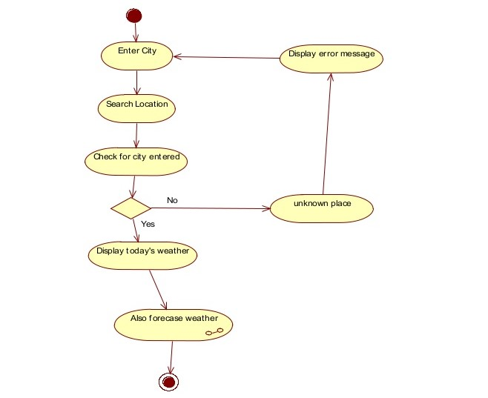

**Conclusion:**

At the end, we will be able to make this live search weather app using react JS in which the user can know about the weather conditions in his/her city or in any other city which the user wants to search.

**References:**

<https://www.beta-labs.in/>

https://rapidapi.com/blog/weather-app-react/